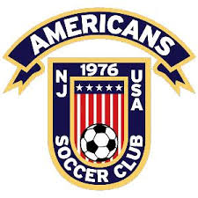

UNIFORM & FAN GEAR ORDERING INFORMATION

2021/2022 SEASON
We are proud to continue our partnership for Uniform Kits and Americans Apparel with:
Berkenmeier Sports Shop, 213 Main St
Hackensack, NJ 07601 - 201-488-2370
Map it
Based on the contract with Adidas, after every 2 years all Americans players must purchase new complete uniform kits.
The 2021-2022 season is year 2 in the current contract, which means only: new players, players requiring larger sizes, or number conflicts require new uniforms or kits.
For NEW players joining the club, you will need to purchase the full kit (this includes your free training shirts).
For RETURNING players that CHANGED NUMBERS, you will need to order a white and blue jersey at a minimum from the optional gear section. Everything else is optional, so if shorts and socks still fit…no need to buy those. Your free training shirts will be provided by us…no need to select.
For RETURNING players that NEED BIGGER SIZES, you can purchase whatever you need in a larger size from the optional gear section. Your free training shirts will be provided by us…no need to select.
For ALL REMAINING RETURNING players, we will automatically provide you with your free training shirts for this year. No need to purchase anything, unless you want optional gear.
WE WILL BE PROVIDING YOUR CHILD'S UNIFORM NUMBER DIRECTLY TO THE SHOP ON YOUR BEHALF.
The ordering link is on the website or below. Here are the steps and information for ordering new uniforms. Please order as soon as possible so that you receive the order prior to the first game of the season in early September.
Sizing: Towards the bottom of this document are some sizing guidelines including how to measure your child and how the measurements correspond to the Jerseys and Shorts. If you are unclear you can always visit Berkenmeier Sports physically to have a uniform fitting.
Step 1: Go to Berkenmeier Sports webstore and Register to create an ecommerce account if you don’t have one. You will be asked for an email only and then will be emailed with a temporary password. Login and change your password immediately by selecting Account Details.

Step 2: Once logged in, select Americans Soccer Club from the top navigation of the site.
Step 3:
For NEW families ordering the whole kit: Select "Players Kit" Category. In this category you will see one item which is the complete player kit. Select that item. Then follow steps to select the size for all items in kit, Jerseys, Shorts, Socks and Training Shirts. You will also be asked to complete the following information 'Americans' checkbox, 'Players Full Name', and select team name from drop down. Then the 'Add to Cart' button will appear and you can add to cart.
You will be taken to the cart where at the top right you can select 'Proceed to Checkout' or on the bottom left you can select 'Continue Shopping' if you want to browse our 'Player optional' and 'Fan Gear' categories. We have some of the basics in the store and we will be adding many more items to our store in the future.
When shopping is completed you can select "Proceed to Checkout".
Note: If you have more than 1 child in the program you can shop for both at once and add multiple kits and products for all children if you like because each item will require you to add player name and team name.
For RETURNING families refreshing jerseys or other items: Select "Player Optional Gear” Category. Select what you need and follow similar process for checking out.
Step 4: Select 'Proceed to Checkout'. On this page complete all the shipping and billing information that is required to process your order. On the right side please select whether you want to pick up your order at the store (free) or pay a flat rate shipping cost to have the order delivered to your home.
Then select the website term and conditions box and select 'Proceed to Paypal'.
Note: You do not need to have or have to create a Paypal account to checkout. Our partner uses Paypal as a payment processor. If you do want to use Paypal you will be instructed to log in or to choose to pay with credit card.
If you want to use your Paypal account log in and follow through the process. If you want use a credit card select that option and follow through the process of entering your payment details in the Paypal screens.
Step 5: After completing the process you will see an order # and the store will also email you an order confirmation. Save your order number and emails. If you are having it shipped to your home you will also receive a shipping confirmation order when it ships out.
If you are going to pick the order up at the store you will receive a pick-up email from the store.
SIZING:
This image below will give you some guidance on how to measure the athlete to determine what size garments that you should order.
Customized (Number, Name etc.) items are not returnable.
If you are not sure about sizing you are welcome to visit ESKI and his staff at the store for a uniform fitting and shop there amazing selection of global futbol apparel and equipment.

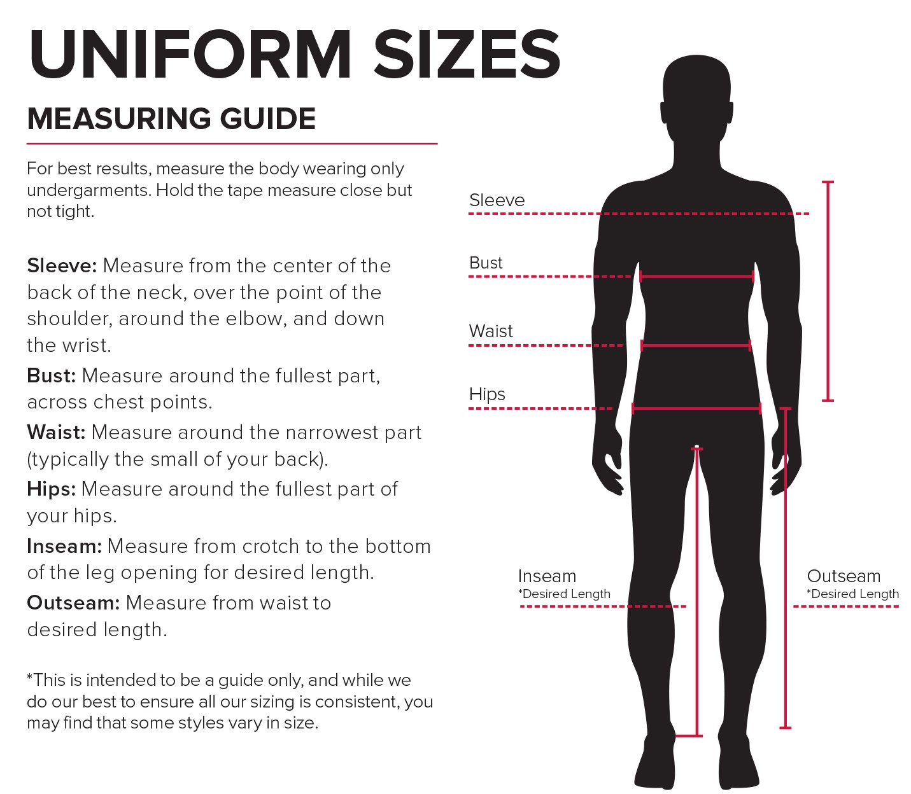
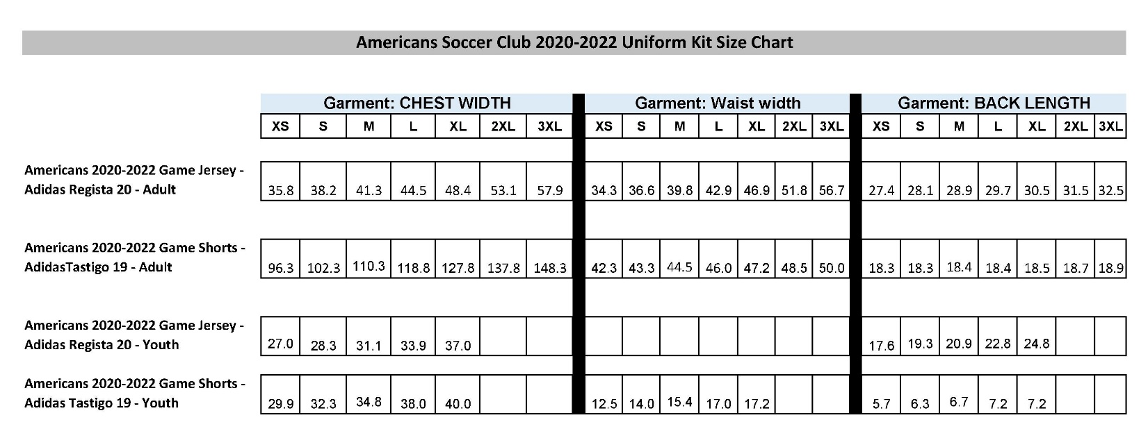

Thank you
Americans Soccer Club!

